COVID-19 INDUSTRY SOCIAL MEDIA CAMPAIGN
#care4frontliners

Thank you for joining the movement! We are stronger together and know that by working together we can create a movement that will make a positive impact on our industry and our communities!
Here’s the plan:
We will collectively get as many salon industry professionals to kick off the campaign by posting on social media the exact same image with the exact same caption on the exact same day (April 27th) to create a true impact.
Share this page with as many salon industry professionals as possible!

For Salons: (Launch date is April 27)
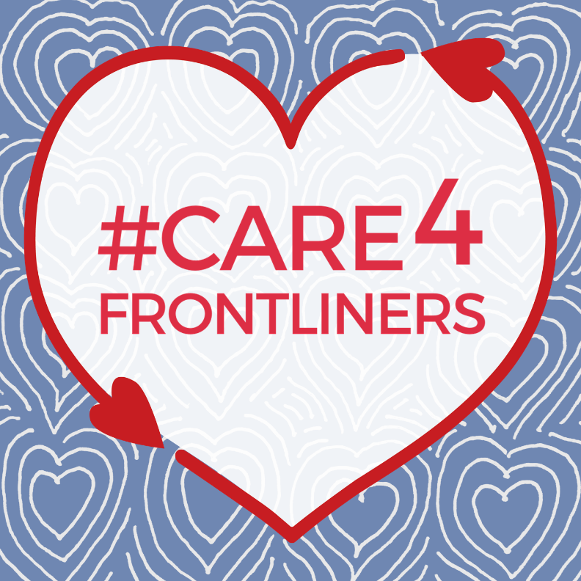
(Suggested Caption)
Show your support! #care4frontliners
Many of you have asked how you can help our community, so today we would like to invite you to become a part of a movement that is building across North America:
We invite you to offer a gift card to our salon to a friend/relative/community member who is working on the frontline of this pandemic: in the healthcare industry, food industry and other important essential services. These heroes have been working tirelessly to take care of our physical health and they will need to be cared for the most, once this is over. We promise that after a beauty experience with our amazing staff, they will feel relaxed, pampered, and revitalized.
Plus, by offering them a gift card to our salon, you’ll not only be treating our frontline workers, but you’ll also be helping a local, small business in your community who wants to make sure we are also there for YOU on the other side of this. To purchase your gift card, (provide details on how to buy gift card at your salon)
Help us spread the word by reposting this image on social media with the hashtag #care4frontliners
(OPTIONAL CONTEST TO ADD TO CAPTION)
For every $1000 in gift cards purchased from our salon, we will give a $xxx (enter the amount you want, we recommend $100) to a local frontline worker as well. We are all in this together!
OR
Repost this image on social media with the hashtag #care4frontliners, tag the frontline worker that you purchased a gift card for and tag our salon to be entered into a draw to win (enter the gift you want to offer here)

For Industry Partners: (Launch date is April 27)
(Suggested Caption)
Show your support! #care4frontliners
Many of you have asked how you can help our community, so today we would like to invite you to become a part of a movement that is building across North America:
We invite you to offer a gift card to your local salon to a friend/relative/community member who is working on the frontline of this pandemic: in the healthcare industry, food industry and other important essential services. These heroes have been working tirelessly to take care of our physical health and they will need to be cared for the most, once this is over. A beauty experience in a salon or spa will help them feel relaxed, pampered, and revitalized.
​Plus, by offering them a gift card to a local salon, you’ll not only be treating our frontline workers, but you’ll also be helping a local, small business in your community.
Contact your local salon or spa to find out how to purchase your gift card, and help us spread the word by reposting this image on social media with the hashtag #care4frontliners

FOLLOW UP IDEAS TO STIMULATE THE MOVEMENT

- Start by reaching out close friends and family to ask them to share the post
- Do a follow up post 2-3 days later (on April 29 or 30th)
  - video message thanking the community for their support, reminding people to participate
  - repost the same image again but change the caption to add a personalized message and thank people for the support received so far. Remember that this is 1st about caring for the frontline workers, 2nd about supporting small business (your salon)
- If you have clients that have tagged you with in their post related to this movement, consider re-posting those posts to showcase that the movement is growing
- The more it gets posted, the more it benefits EVERYONE – frontline workers, salons, society

